# Configure the managed disk by using Azure PowerShell

#### **Start a PowerShell session in Azure Cloud Shell**

$location = (Get -AzResourceGroup -Name az104-03b-rg1).Location

$rgName = 'az104-03c-rg1'

New-AzResourceGroup -Name $rgName -Location $location

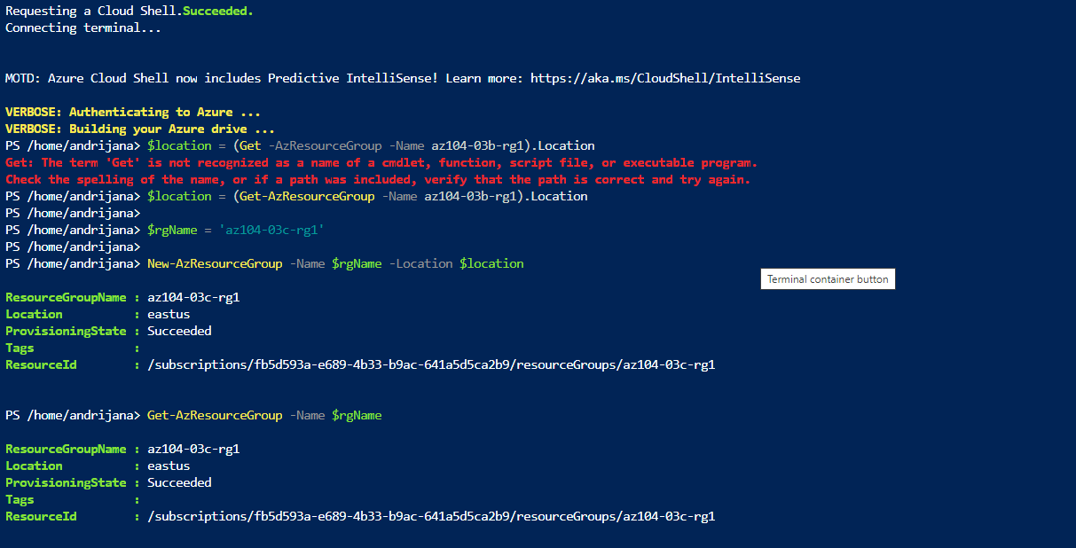

Get-AzResourceGroup -Name $rgName

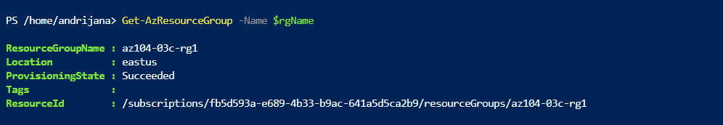

#### **Create a resource group and an Azure managed disk by using Azure PowerShell**

To create a new managed disk with the same characteristics as those you created in the previous labs of this module, run the following:

$diskConfig = New-AzDiskConfig `

-Location $location `

-CreateOption Empty `

-DiskSizeGB 32 `

-Sku Standard_LRS

$diskName = 'az104-03c-disk1'

New-AzDisk `

-ResourceGroupName $rgName `

-DiskName $diskName `

-Disk $diskConfig

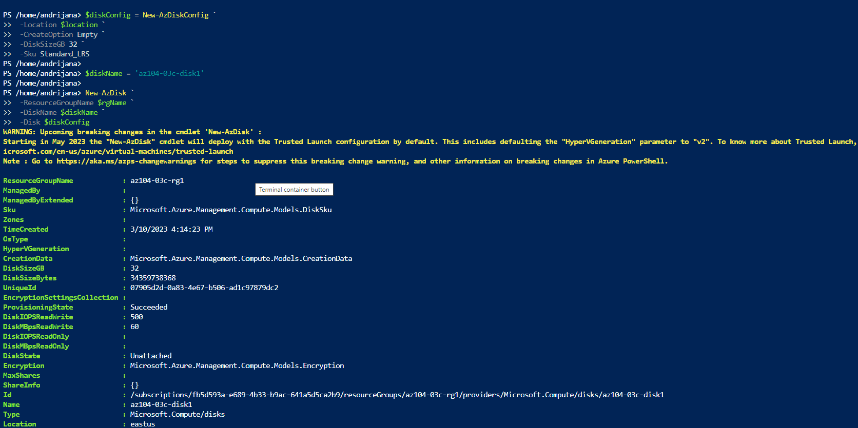

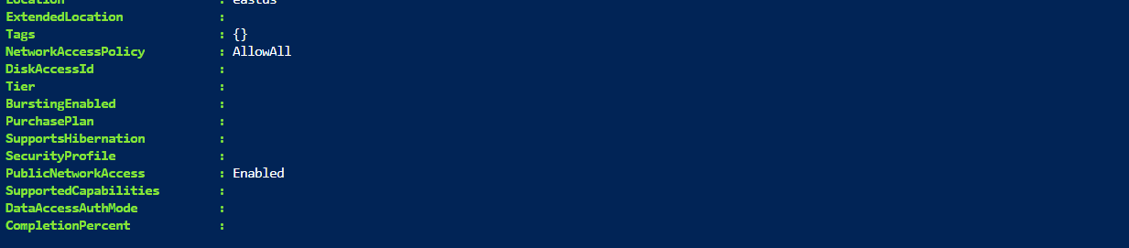

To retrieve properties of the newly created disk, run the following:

Get-AzDisk -ResourceGroupName $rgName -Name $diskName

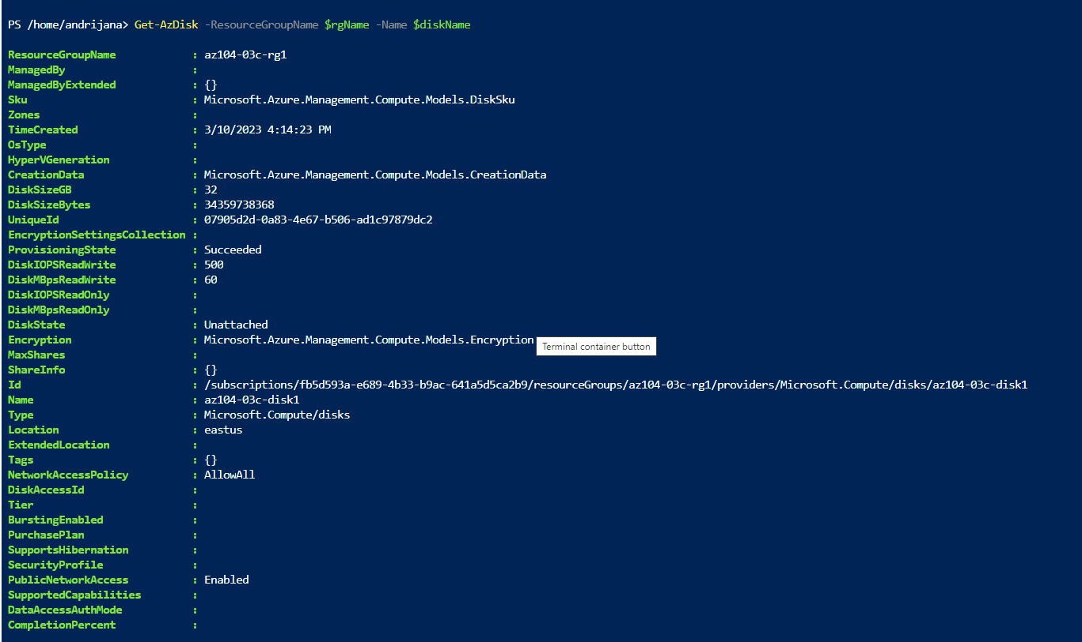

#### 

#### 

#### 

#### 

#### 

#### 

#### **Configure the managed disk by using Azure PowerShell**

New-AzDiskUpdateConfig -DiskSizeGB 64 | Update-AzDisk -ResourceGroupName $rgName -DiskName $diskName

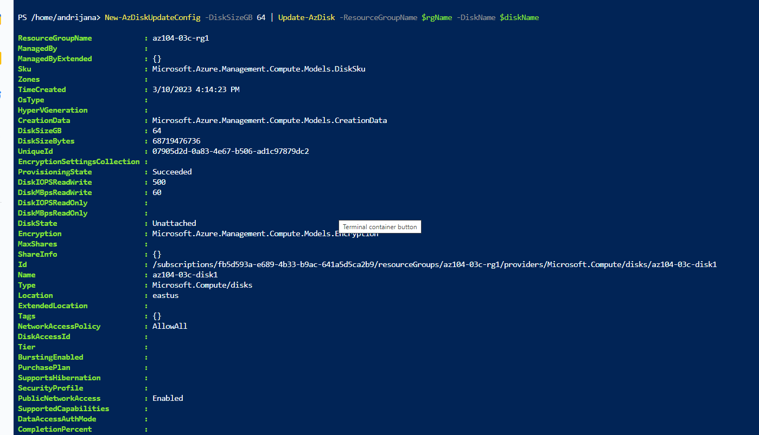

Get-AzDisk -ResourceGroupName $rgName -Name $diskName

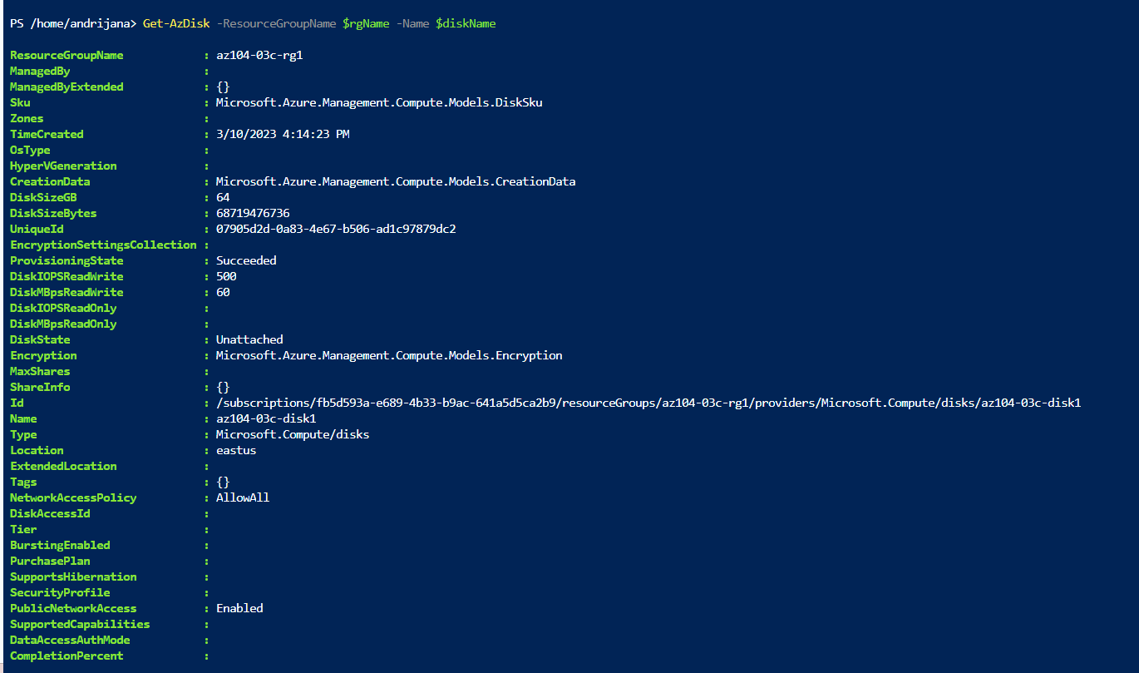

(Get-AzDisk -ResourceGroupName $rgName -Name $diskName).Sku

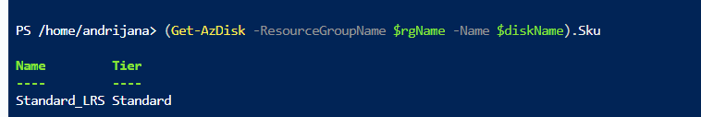

New-AzDiskUpdateConfig -Sku Premium_LRS | Update-AzDisk -ResourceGroupName $rgName -DiskName $diskName

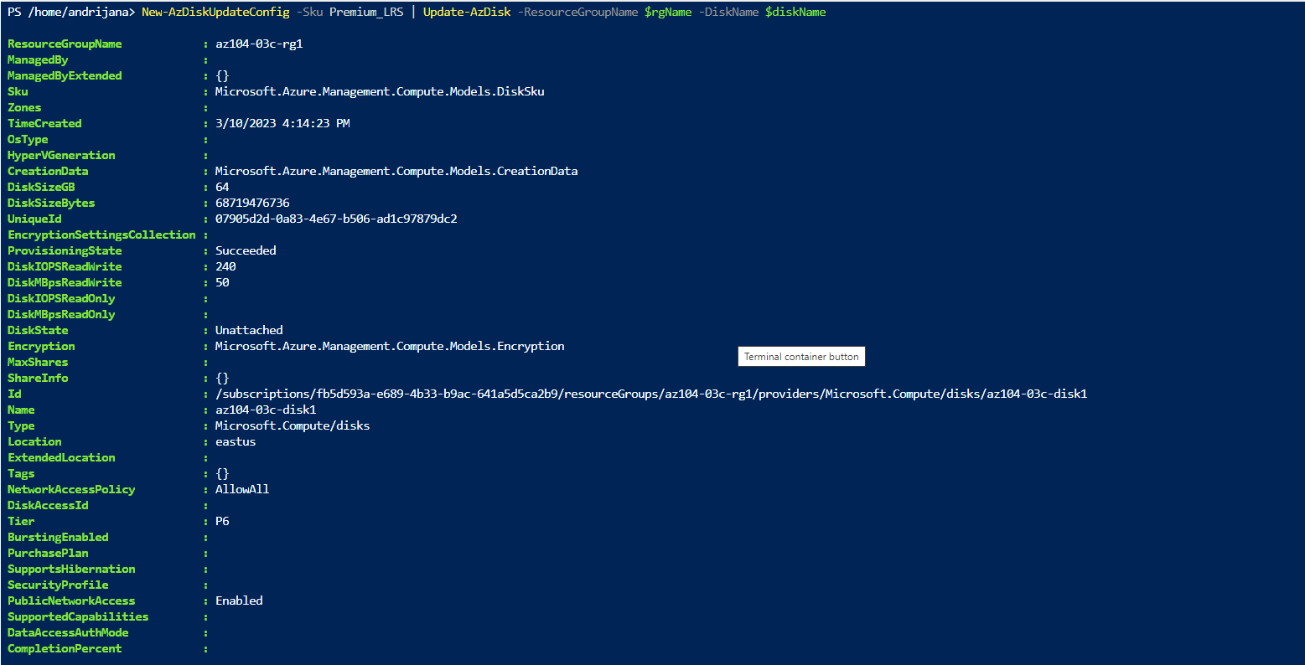

(Get-AzDisk -ResourceGroupName $rgName -Name $diskName).Sku

